**Inner Class**

Sometimes we can declare a class inside another class such type of classes are called Inner classes.

Inner classes concepts introduced in 1.1v to fix GUI bugs as a part of event handling but because of powerful features and benefits of inner classes slowly programmer started using in regular coding also

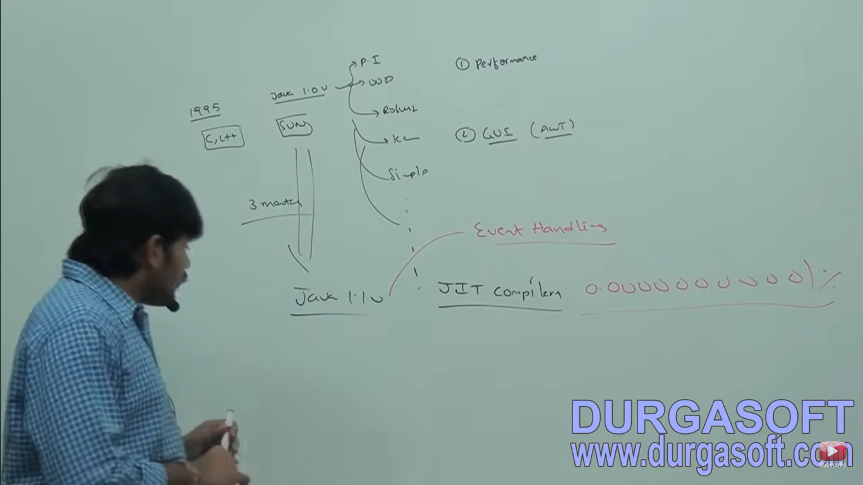

Without existing one type of object if there is on chance of existing another type of object then we should go for inner classes.

University consisting of several departments without existing university, there is no chance of existing departments hence we have to declare department class inside university class

**class University{**

**class Department{**

**}**

**}**

Without existing Car Object there is no chance of existing Engine object hence we have to declare engine class inside Car class.

**class Car{**

**class Engine{**

**}**

**}**

Ex 3: Map is a group of key-value pairs and each key-value pair is called an entry. Without existing map object there is no chance of exisiting entry object. Hence interface entry is defined inside Map interface.

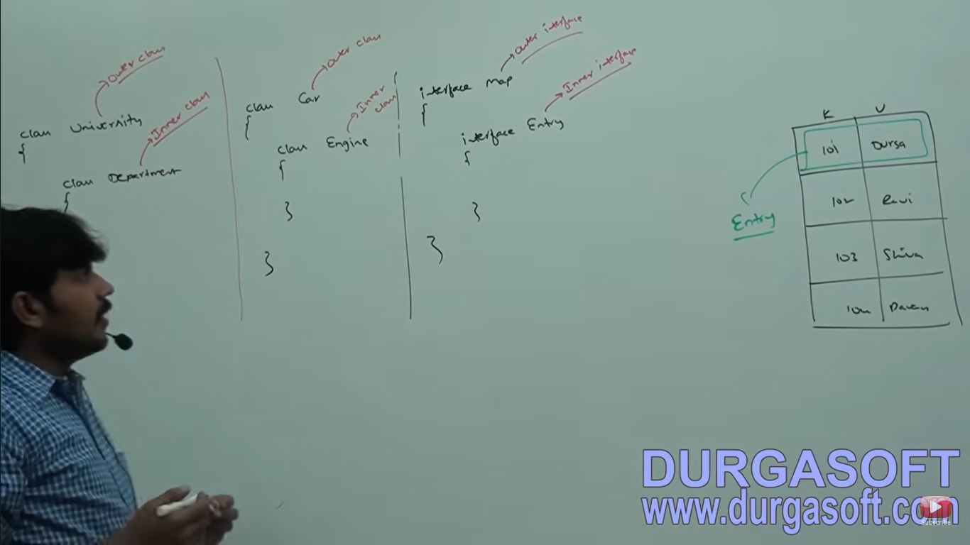

Without existing outer class object there is no chance of existing inner class object. The relation between outer class and inner class **is not is-A and it is has-A relationship (Composition or Aggregation).**

**There are four categories of inner class.**

1. **Normal or Regular Inner class**
2. **Method local Inner classes**
3. **Anonymous Inner class**
4. **Static Nested classes**

**Based on position of declaration and behavior all inner class are divided into above 4 types.**

**Normal or Regular Inner Classes**

class Outer{

class Inner{ 🡪 **Normal or regular inner class**

}

}

Declaring any named class directly inside a class without static modifier such type of inner classes is called normal or regular inner class.







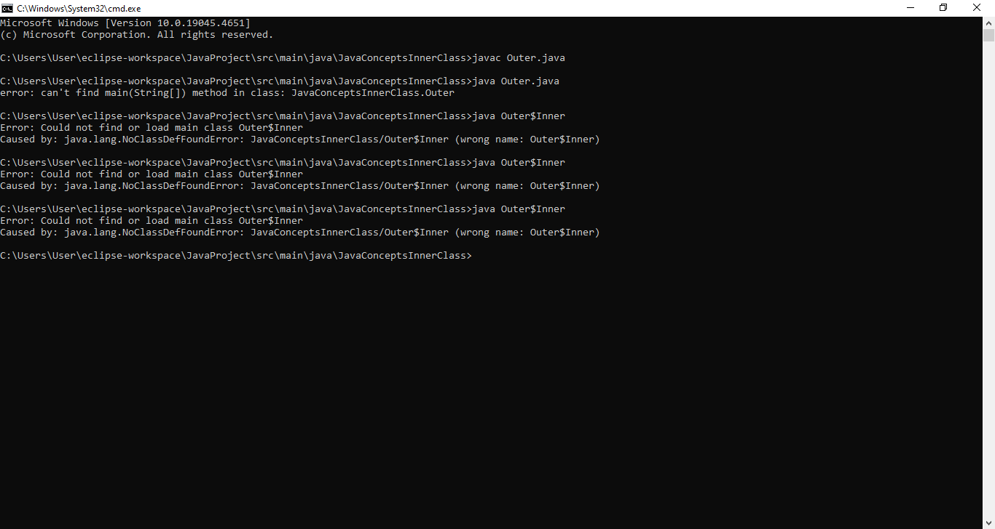

**Ex2: If we declare main method inside inner class we will get Compile time error**

public class Outer2 {

class inner2{

// public static void main(String[] args) {

// System.out.println("Inside inner main method");

// }

}

}

Inside inner class we can’t declare any static members, hence we can’t declare main method and we can’t run inner class directly from command prompt.



**Accessing Inner class code**

Case 1: Accessing inner class code from static area of outer class

package JavaConceptsInnerClass;

public class Outer4 {

class Inner4{

public void m1() {

System.out.println("Inner class method");

}

}

public static void main(String[] args) {

//1st approach

Outer4 o = new Outer4();

Outer4.Inner4 i = o.new Inner4();

i.m1();

//2nd approach

new Outer4().new Inner4().m1();

//3rd approach

Outer4.Inner4 i1 = new Outer4().new Inner4();

i1.m1();

}

}



**Case 2: Accessing Inner class code from instance area of outer class**

**package JavaConceptsInnerClass;**

**class Outer5 {**

**class Inner5{**

**public void m1() {**

**System.out.println("Inner class method");**

**}**

**}**

**public void m2() {**

**Inner5 i = new Inner5();**

**i.m1();**

**}**

**public static void main(String[] args) {**

**Outer5 o = new Outer5();**

**o.m2();**

**}**

**}**

**Case 3: Accessing Inner class code from outside of outer class**

**package JavaConceptsInnerClass;**

**class Outer6 {**

**class Inner6{**

**public void m1() {**

**System.out.println("Inner class method");**

**}**

**}**

**}**

**class Test{**

**public static void main(String[] args) {**

**Outer6 o = new Outer6();**

**Outer6.Inner6 i = o.new Inner6();**

**i.m1();**

**}**

**}**





**Regular Inner Class**

**We can access both static and non static members of outer class directly inside the inner class.**

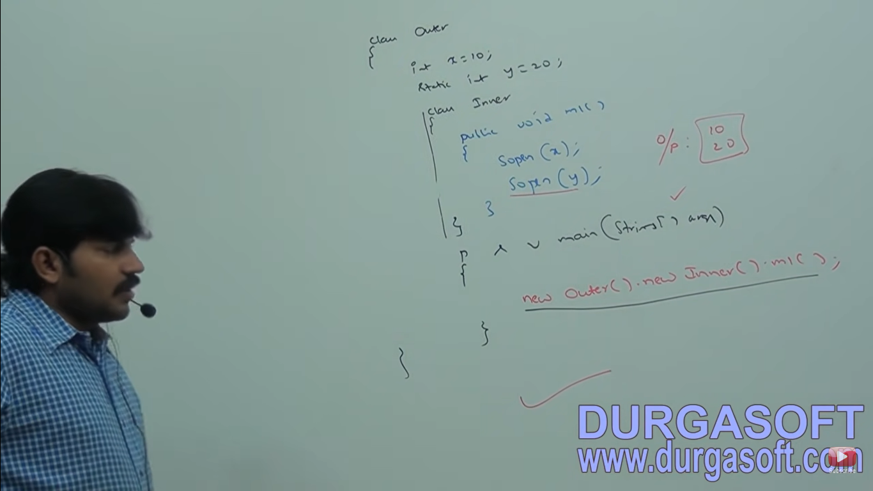

**Case : Variables in Outer and Inner class and in instance of inner class**

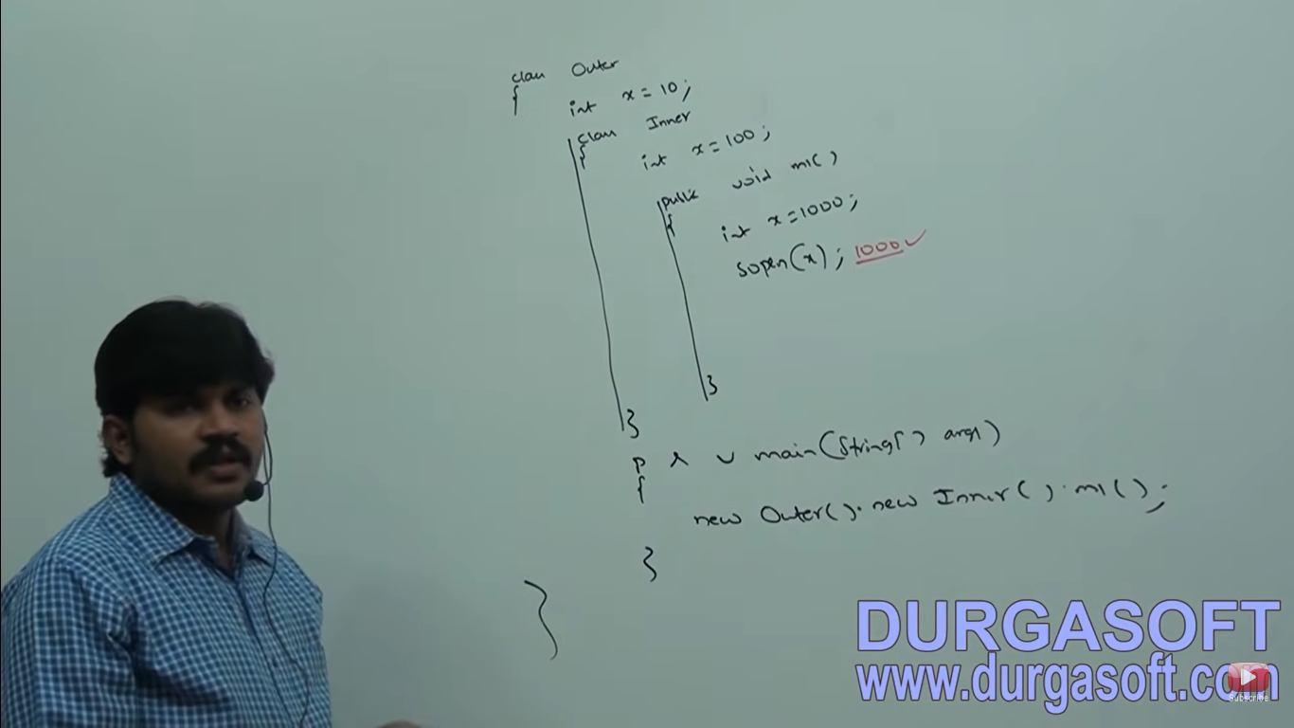

**package JavaConceptsInnerClass;**

**class Outer8 {**

**int x =10;**

**class Inner8{**

**int x =100;**

**public void m1() {**

**int x =1000;**

**System.out.println(x);**

**System.out.println(this.x);**

**System.out.println(Outer8.this.x);**

**}**

**}**

**public static void main(String[] args) {**

**new Outer8().new Inner8().m1();**

**}**

**}**

**Within the inner class this always refers current inner class object. If we want to refer current outer class object we have to use Outerclassname.this.varaiablename**

**Modifiers applicable to outer and Inner class**

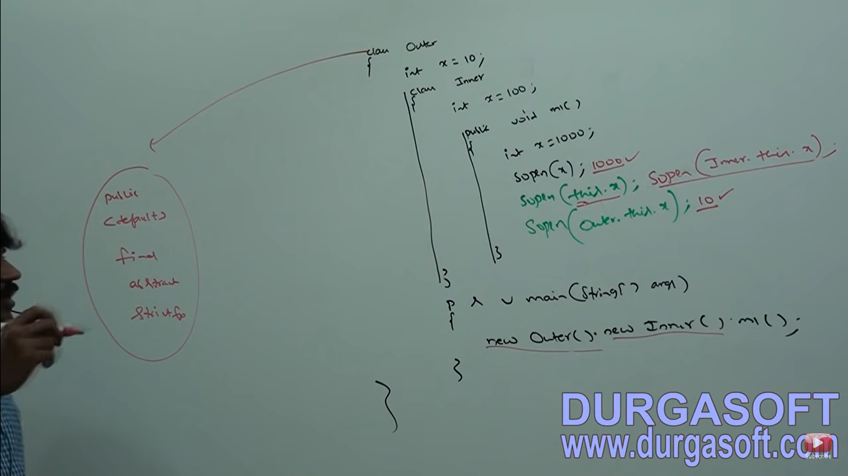

Inner class modifiers:

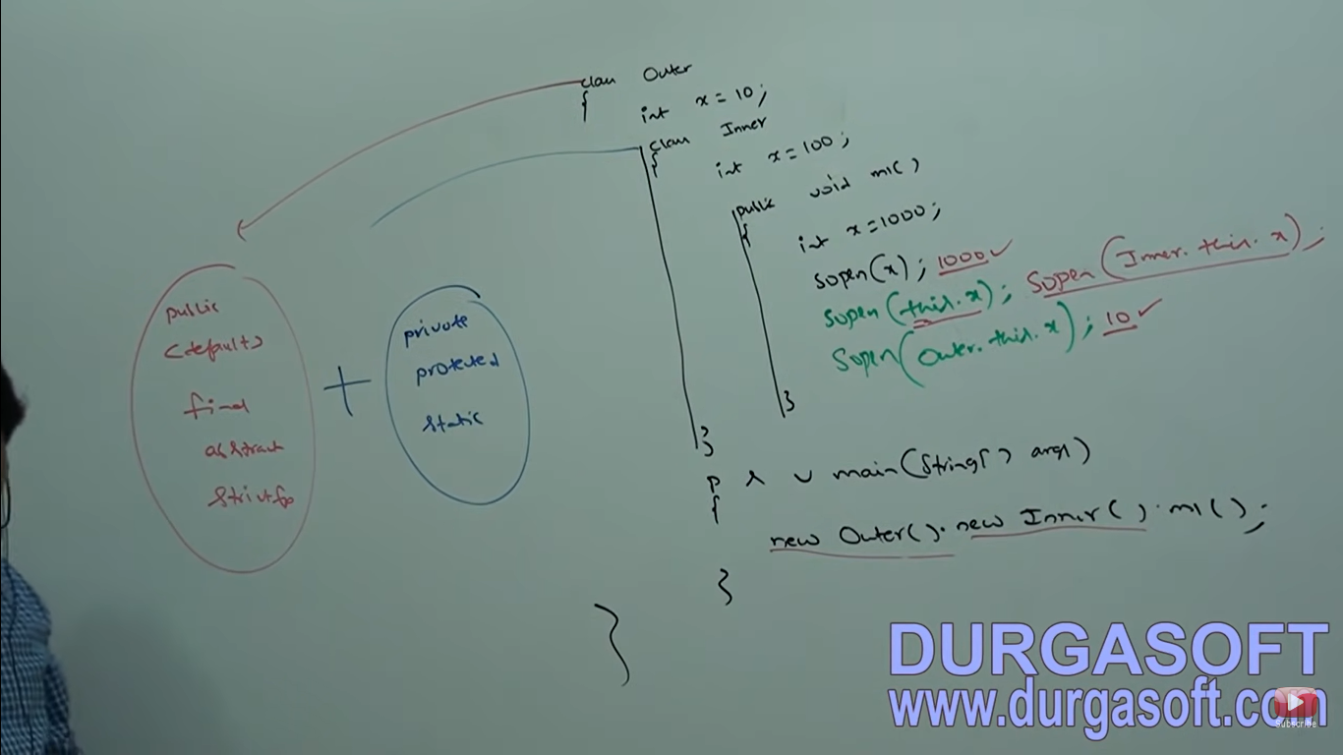The only applicable modifiers for outer classes are:

1. Public
2. Default
3. Final
4. Abstract
5. Strictfp

For Inner class:

1. Private
2. Protected
3. Static

**Nesting of inner classes**

Inside inner class we can declare another inner class that is nesting of inner classes is possible.

package JavaConceptsInnerClass;

class A{

class B{

class C{

public void m1() {

System.out.println("Innermost class method");

}

}

}

}

public class NestingOfInnerClass {

public static void main(String[] args) {

A a = new A();

A.B b = a.new B();

A.B.C c = b.new C();

c.m1();

}

}



**Method Local Inner Classes**

Sometimes we can declare a class inside a method such type of inner classes are called method local inner classes.

**Nested method concept not allowed in java we will get compile time error.**

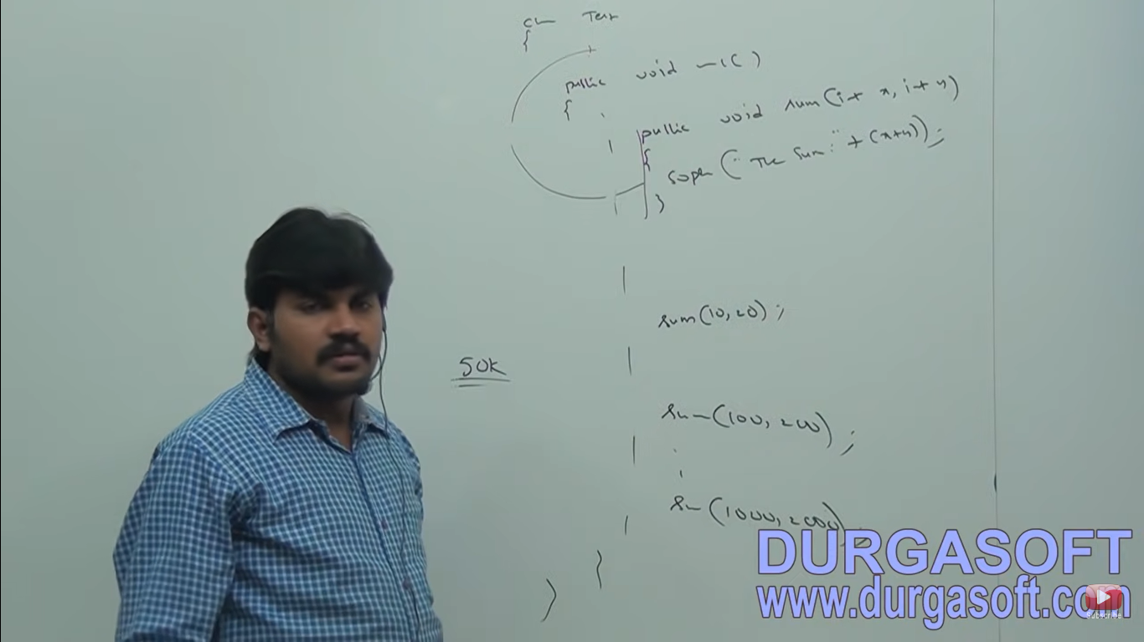

If sum() method required only for m1() method then not recommended to declare it in class level and nested method concept not allowed in java so we can use inner class inside method.

The main purpose of method local inner class is to define method specific repeatedly required functionality. Method local inner classes are best suitable to meet nested method requirements.

We can access method local inner classes only within a method where we declare outside of the method we can’t access because of it’s less scope, method local inner classes are most rarely used type of inner classes.

package JavaConceptsInnerClass;

class MthodLocalInnerClass {

public void m1() {

class InnerSum {

int sum;

public void sum(int x, int y) {

sum = x + y;

System.out.println(sum);

}

}

InnerSum s = new InnerSum();

s.sum(10,20);

}

public static void main(String[] args) {

MthodLocalInnerClass ms = new MthodLocalInnerClass();

ms.m1();

}

}



If we declare inner class directly inside a instance method then from that method local inner class we can access both static and non static members of outer class directly.

But If we declare inner class inside static method then we can access only static member of outer class directly from that method local inner class.

**Declaring Inner class inside instance method**

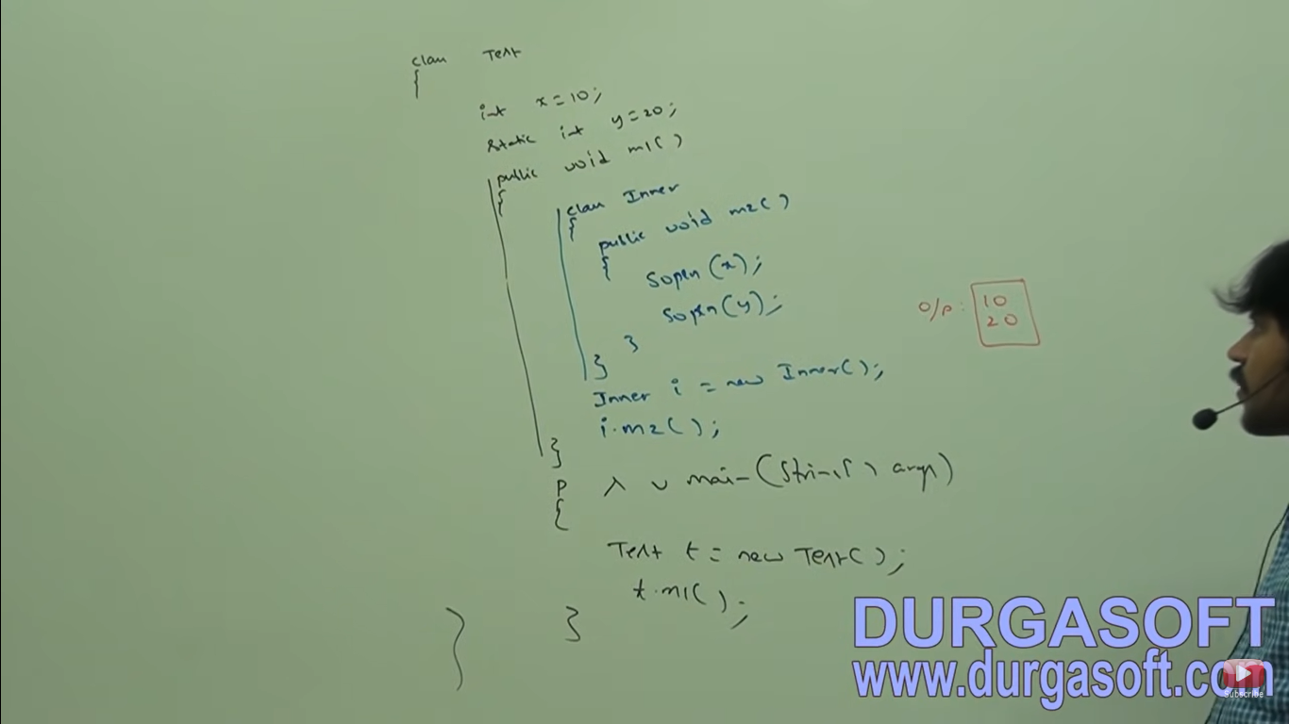

**Declaring inner class inside static method**

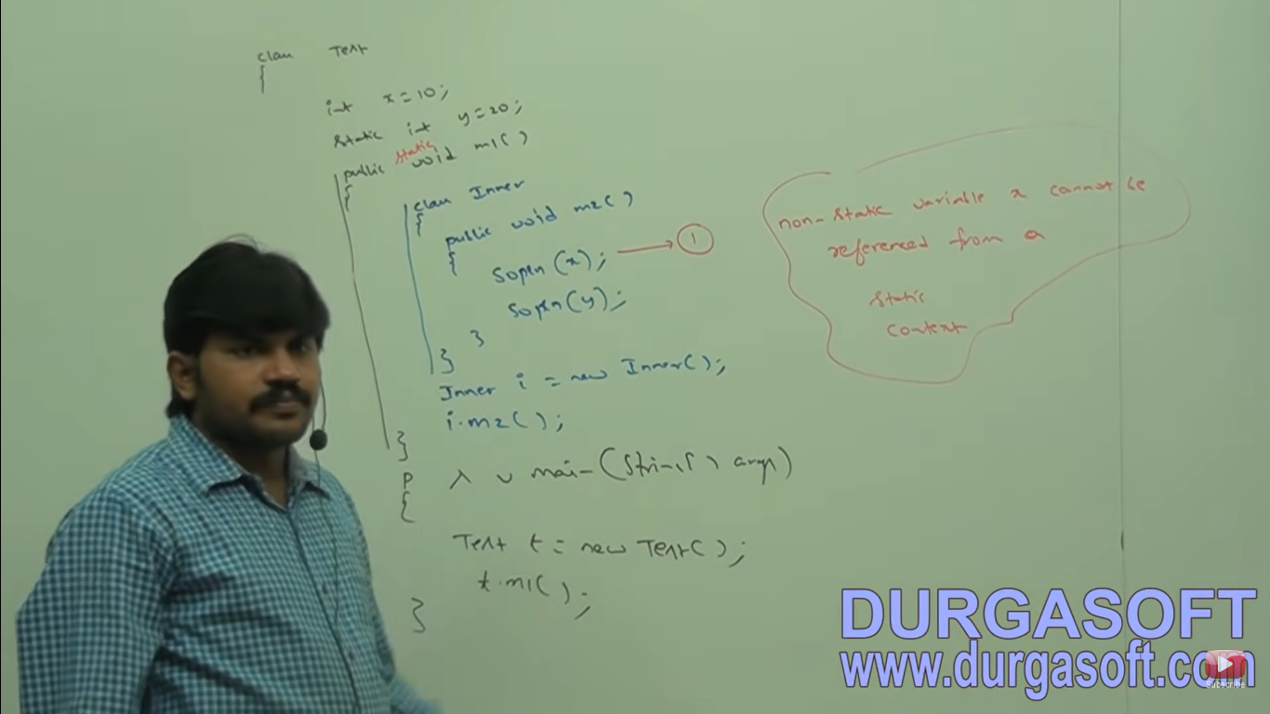

**From method local inner class we can’t access local variables of the method in which we declare inner class. If the local variable declared as final then we can access.**

**package JavaConceptsInnerClass;**

**class MethodInnerClassEx4 {**

**public void m1() {**

**int x=10;**

**x =10; //CE: Local variable x defined in an enclosing scope must be final or effectively final**

**class Innerclass{**

**public void m2() {**

**System.out.println(x);**

**}**

**}**

**Innerclass i = new Innerclass();**

**i.m2();**

**}**

**public static void main(String[] args) {**

**MethodInnerClassEx4 ms = new MethodInnerClassEx4();**

**ms.m1();**

**}**

**}**

**If we declare x as final then we won’t get any compile time error.**

1. **Local variable will be store in stack and object variable will be store in heap memory and every final variable**



**Local variable will be replaced by value at compile time only.**

**Question 1: Consider the following code**

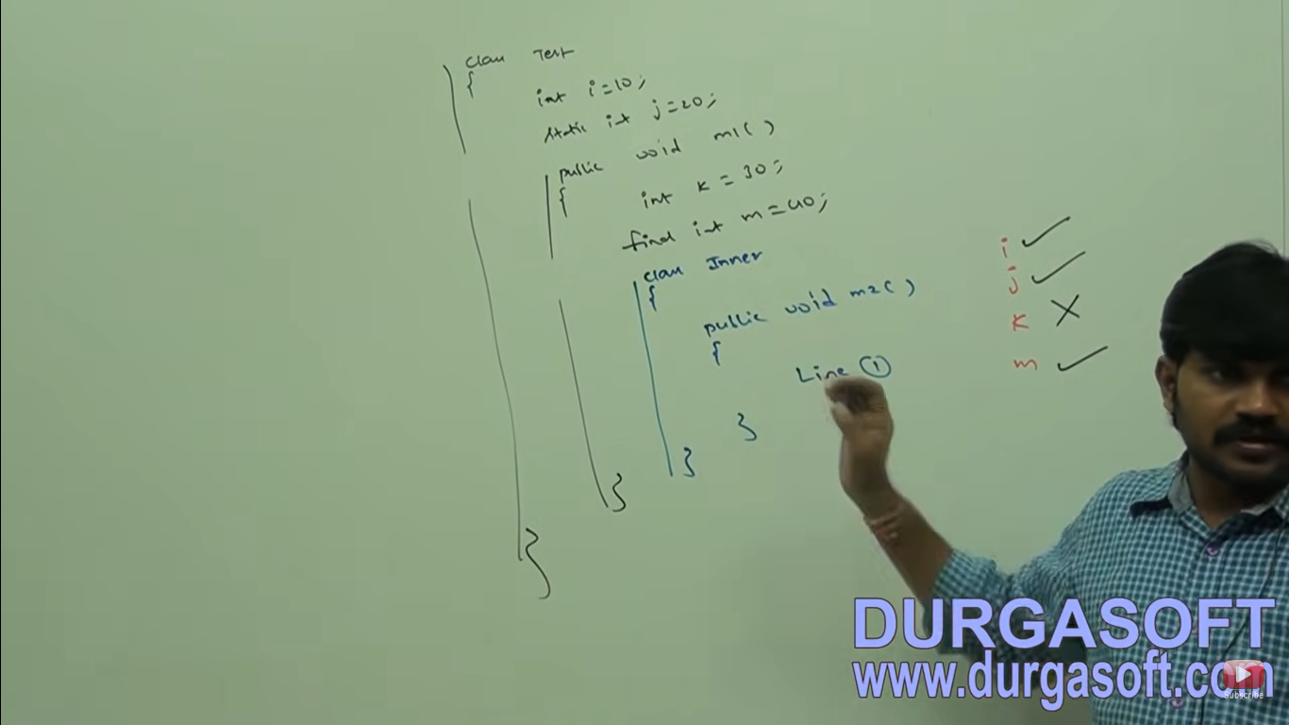

**Question 2: If we declare m1() method as static then at below line 1 which variables we access directly?**

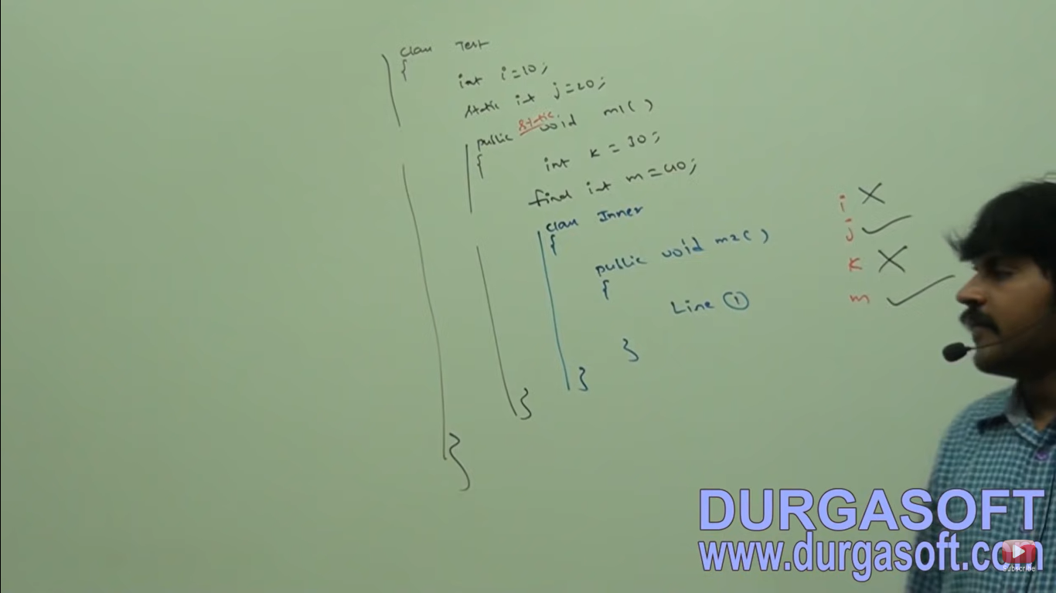

**Question 3: If we declare m2() method as static inside inner class we will get CE as we can’t declare static members inside inner class**

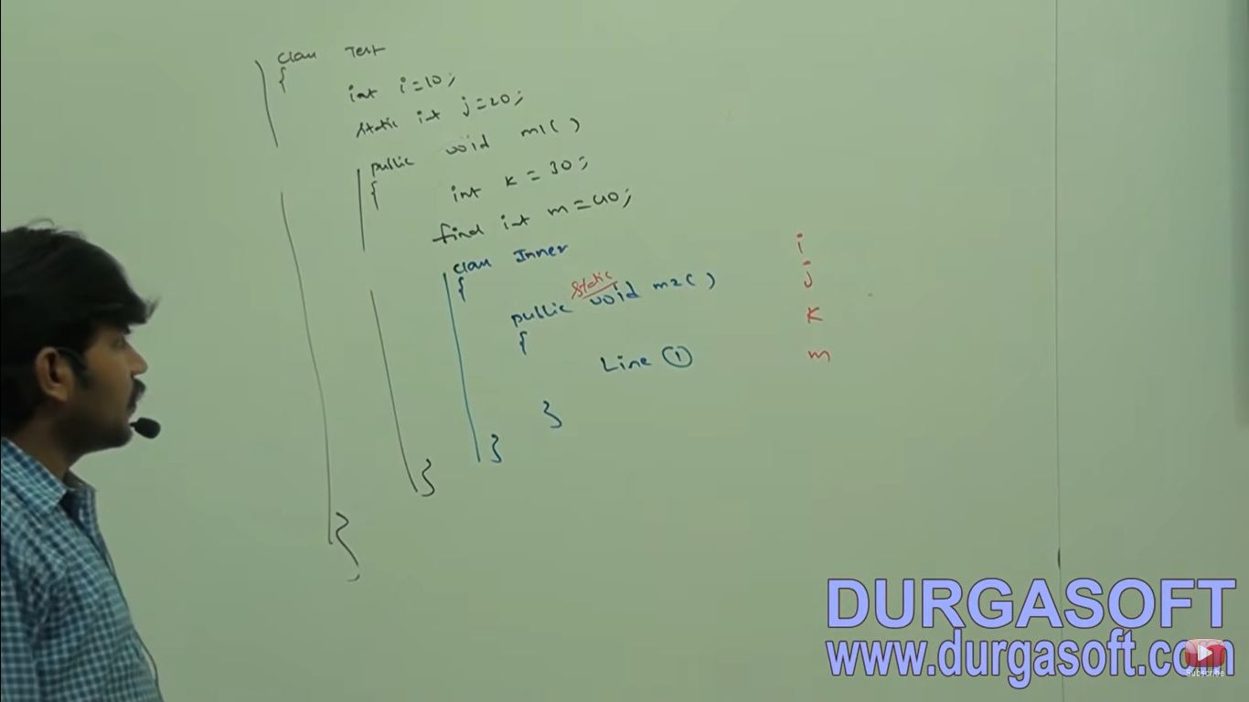

**Note – Only applicable modifiers for Method local inner classes are:**

1. **Final**
2. **Abstract**
3. **Strictfp**

**If we are trying to apply Any other modifier then we will get CE.**

**Anonymous Inner Class**

Sometimes we can declare Inner class without name such type of inner classes are called Anonymous inner classes.

The main purpose of anonymous inner classes is just for instant use. (One time usage) we have anonymous array and anonymous classes.

Based on declaration and behavior there are three types of Anonymous Inner Classes:

1. **Anonymous Inner class that extends a class**
2. **Anonymous inner class that implements an interface**
3. **Anonymous inner class that define inside arguments.**

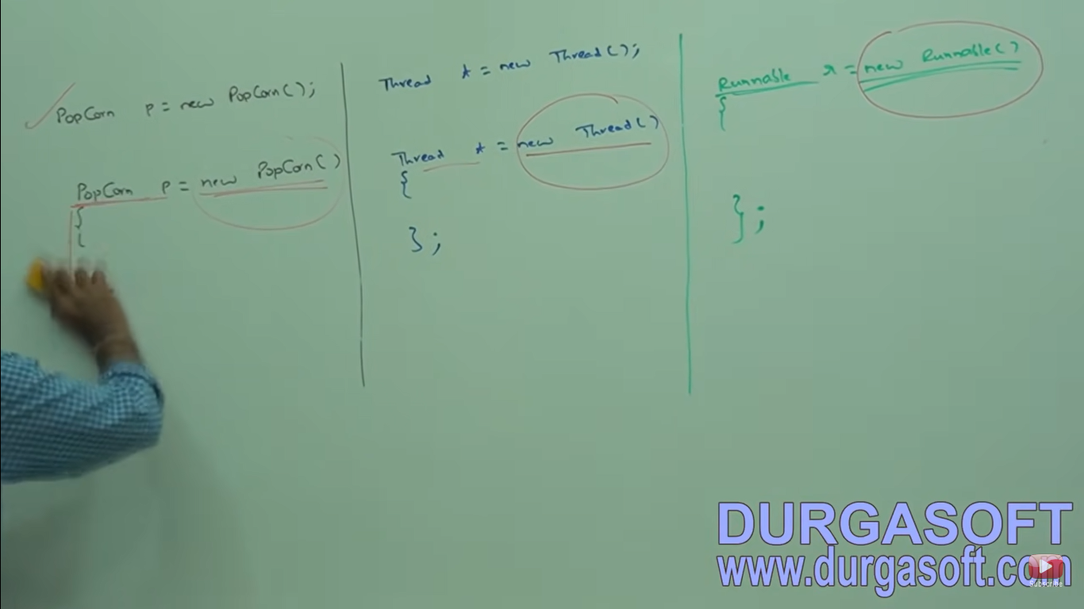

**Anonymous class that extends Inner class**

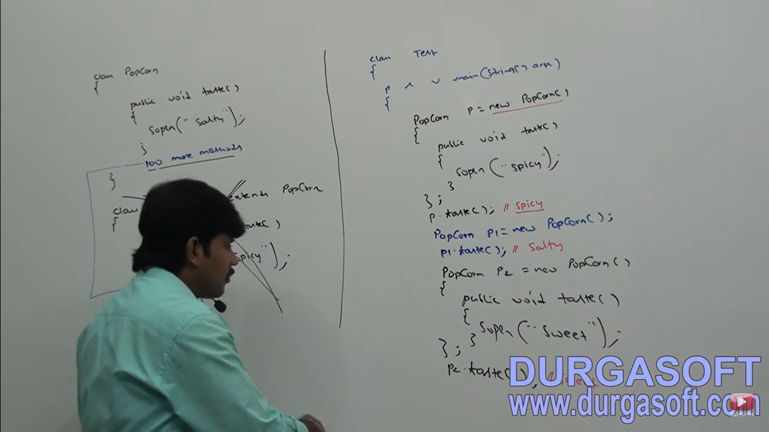

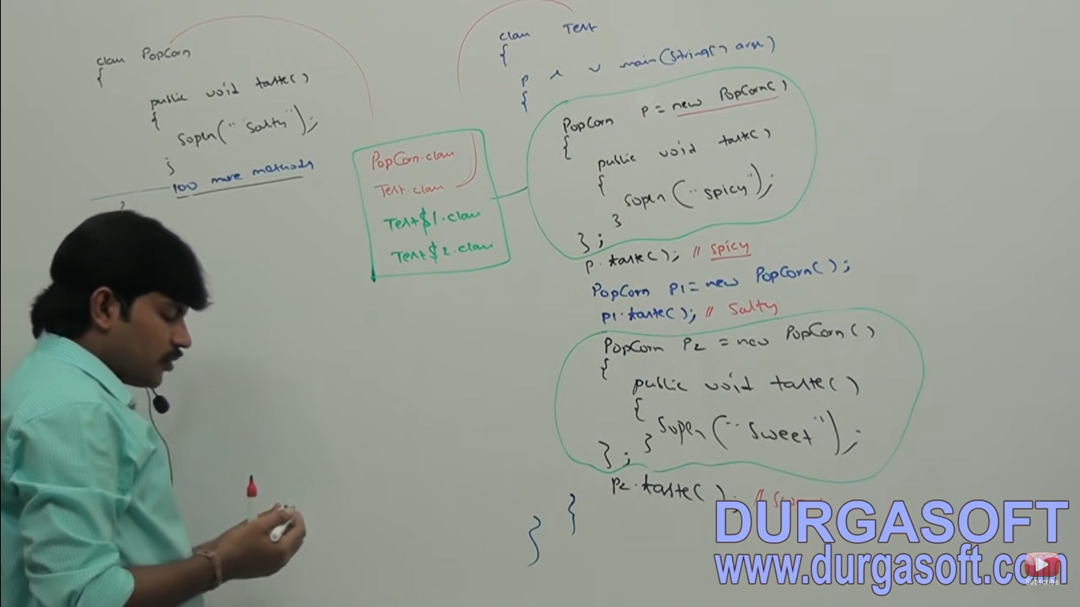

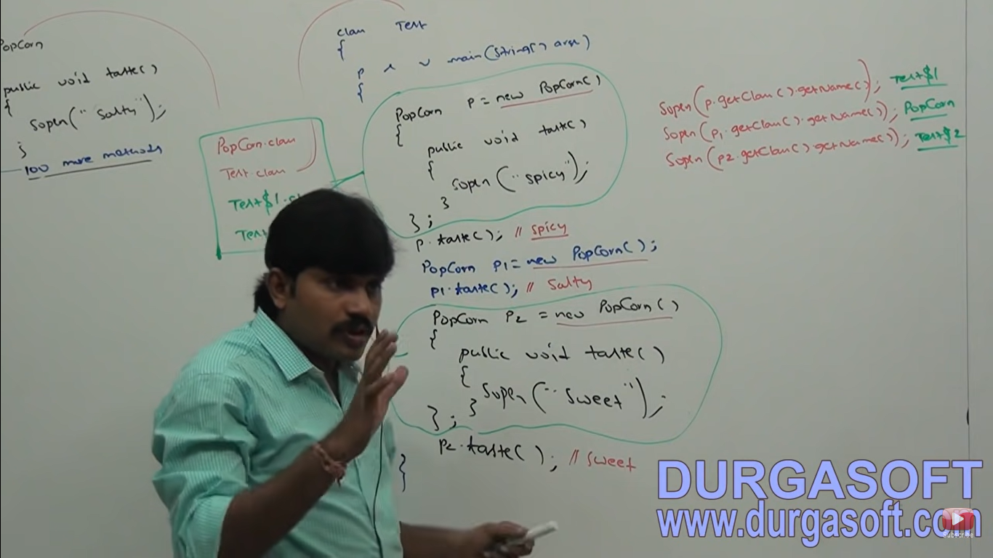

1. We are declaring a class that extends Popcorn without name (Anonymous Inner class)
2. In the child class we are overriding taste() method
3. For that child class we are creating an object with Parent reference.



**Defining a thread by extending Thread class**

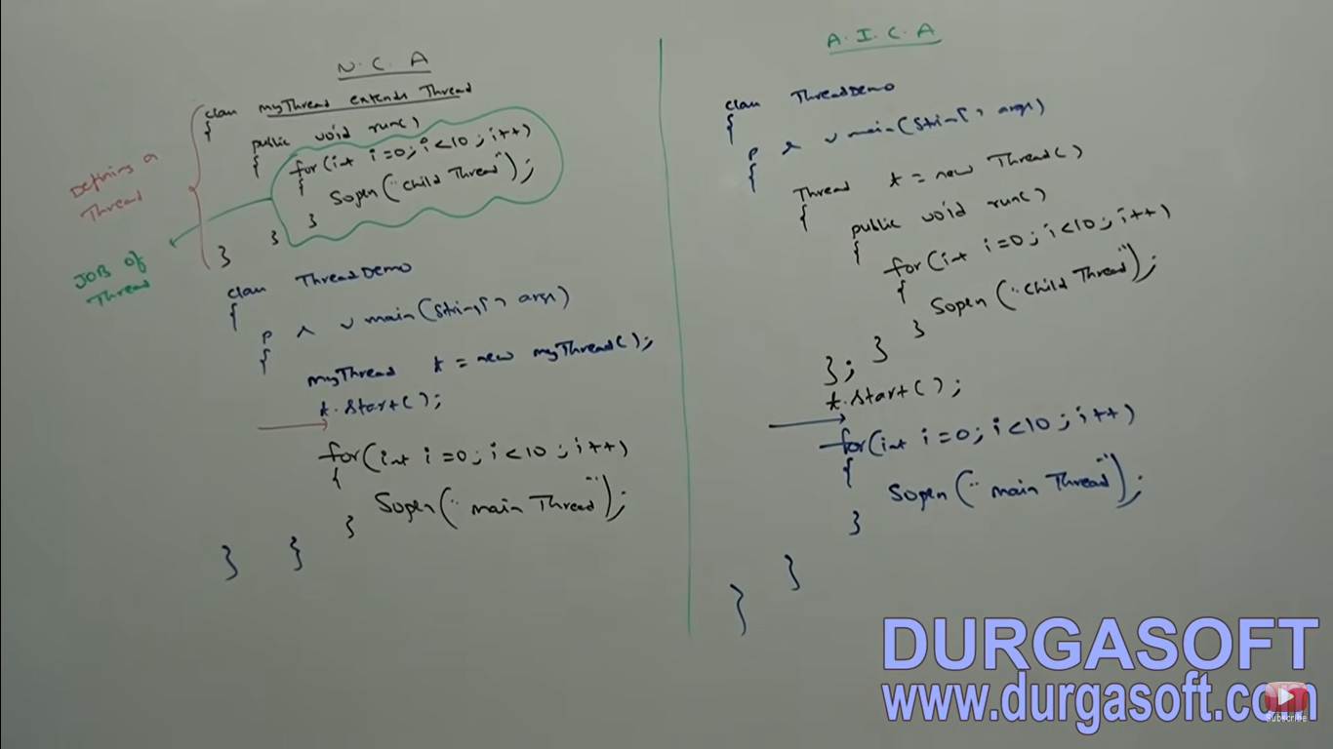

**Anonymous Inner Class that implements an Interface**

**Defining a thread by implementing Runnable interface.**

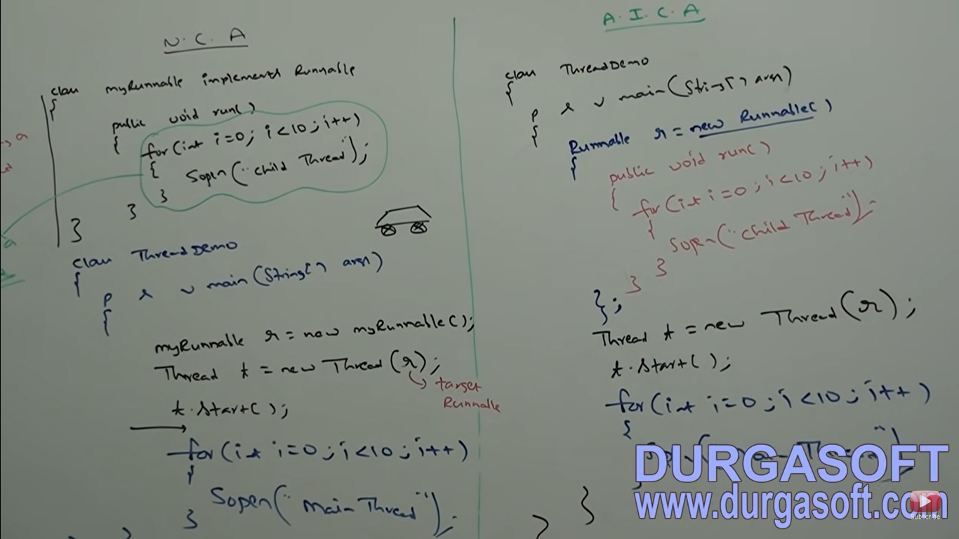

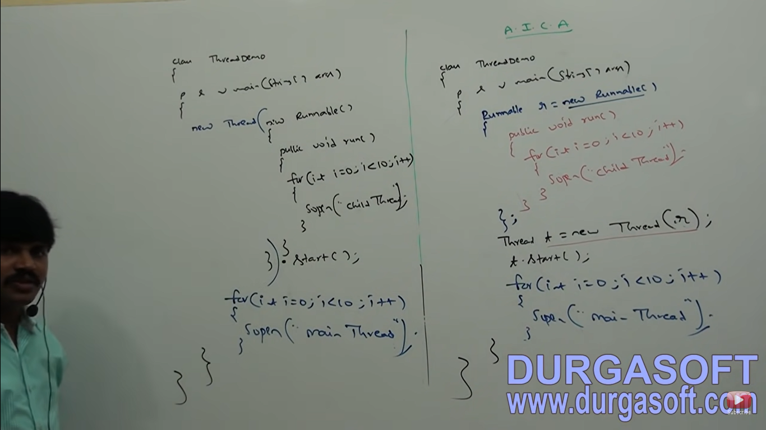

**Normal Java Class Vs Anonymous Inner Class**

1. A normal Java class can extend only one class at a time. Of course anonymous inner class also can extend only one class at a time.
2. A normal Java class can implement any number of interfaces simultaneously. But Anonymous inner class can implement only one interface at a time
3. A normal Java class can extends another class and can implement any number of interfaces simultaneously but anonymous inner class can extend a class or can implement an interface but not both simultaneously.
4. In normal Java class we can write any number of constructors simultaneously. But in anonymous inner classes we can’t write any constructor explicitly (because the name of the class and the name of the constructor must be same but anonymous inner classes not having any name)

**Note – If the requirement is standard and required several times then we should go for normal top level class.**

**If the requirement is temporary and the required only once (Instant use) then we should go for Anonymous inner class.**

**Where Anonymous class are best suitable**

We can use anonymous inner classes frequently in GUI based applications to implement event handling. 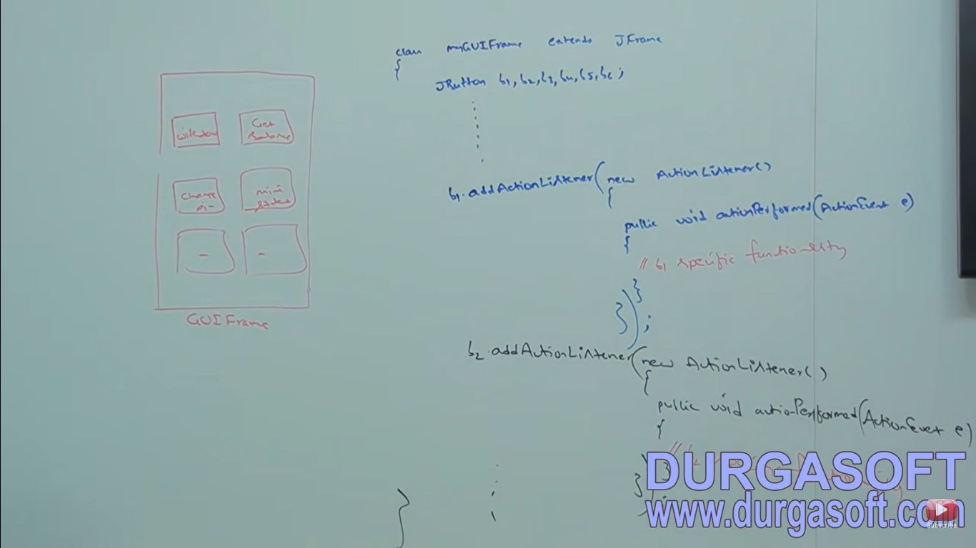

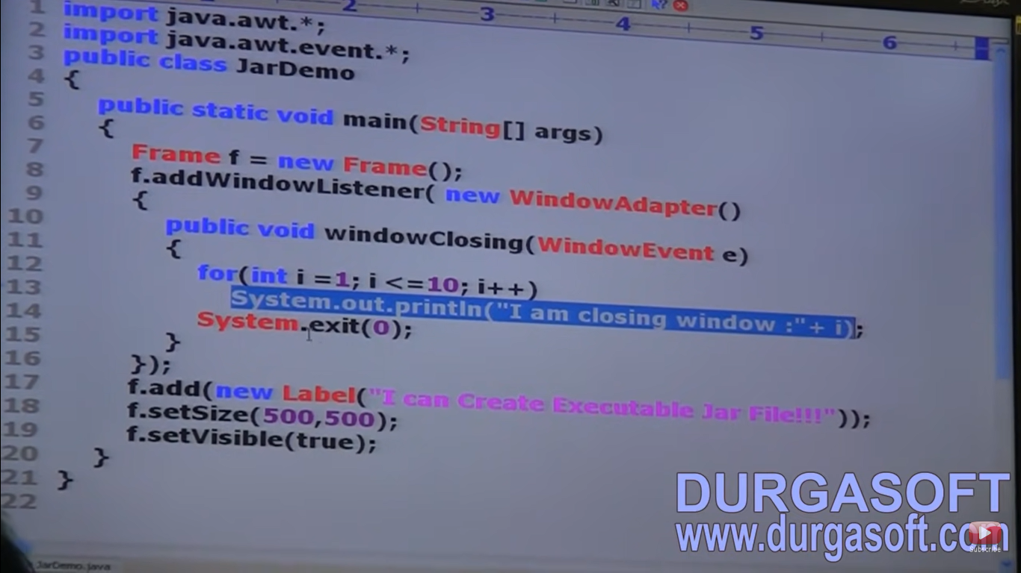

1. Sometimes we can declare inner class with static modifier such type of inner classes are called static nested classes.
2. In the case of normal or regular inner class without existing outer class object there is no chance of existing inner class object that is inner class object is strongly associated with outer class object. But in the case of static nested classes without existing outer class object there maybe a chance of existing nested class object. Hence static nested class object is not strongly associated with outer class object.

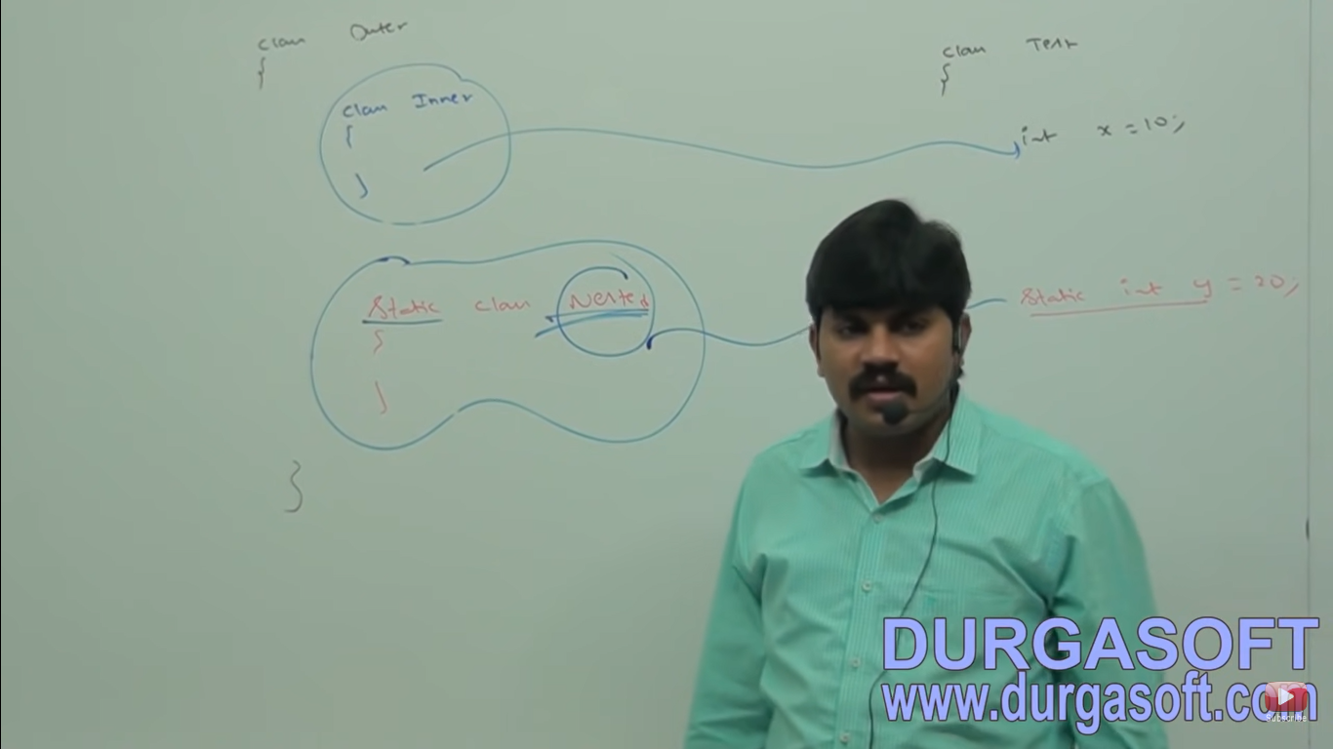

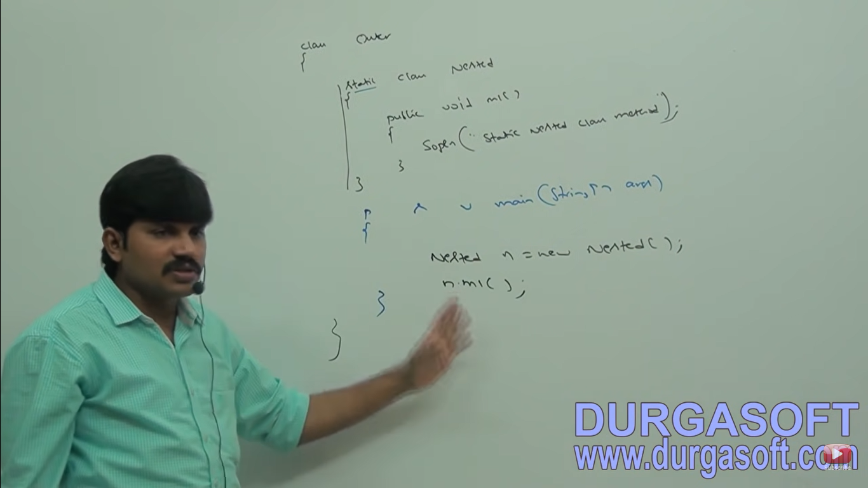

If we want to create nested class object from outside of outer class then we can create as follows:

Outer.Nested n = new Outer().Nested();

**Outer and Static Nested class Both having main method**

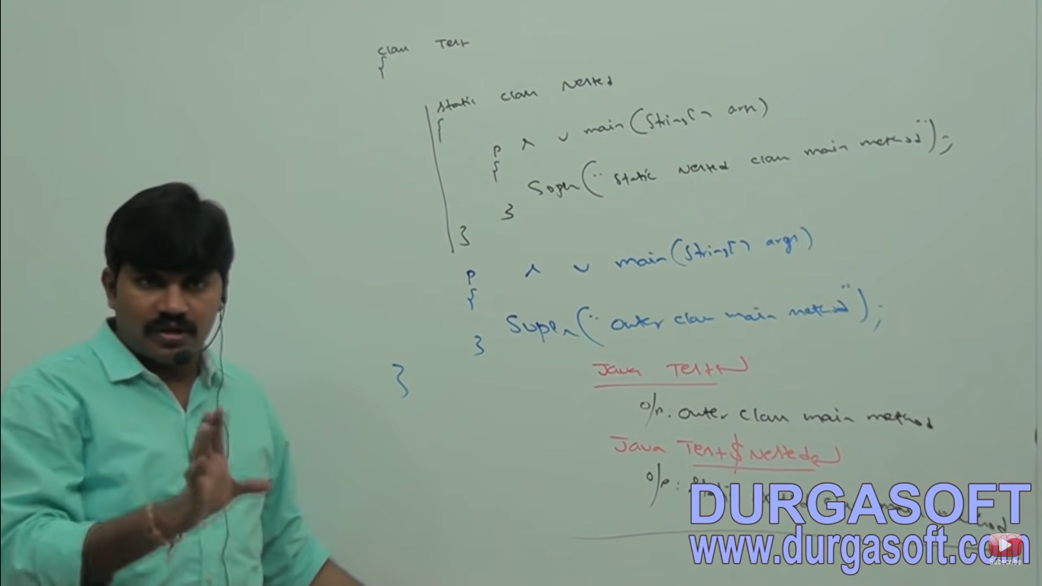

In normal or regular inner classes we can’t declare any static members

But in static nested classes we can declare static members including main method. Hence we can invoke static nested class directly from command prompt.

**Case: From Normal or regular inner classes we can access both static and non static members of outer class directly. But from static nested classes we can access static members of outer class directly and we can’t access non-static members.**

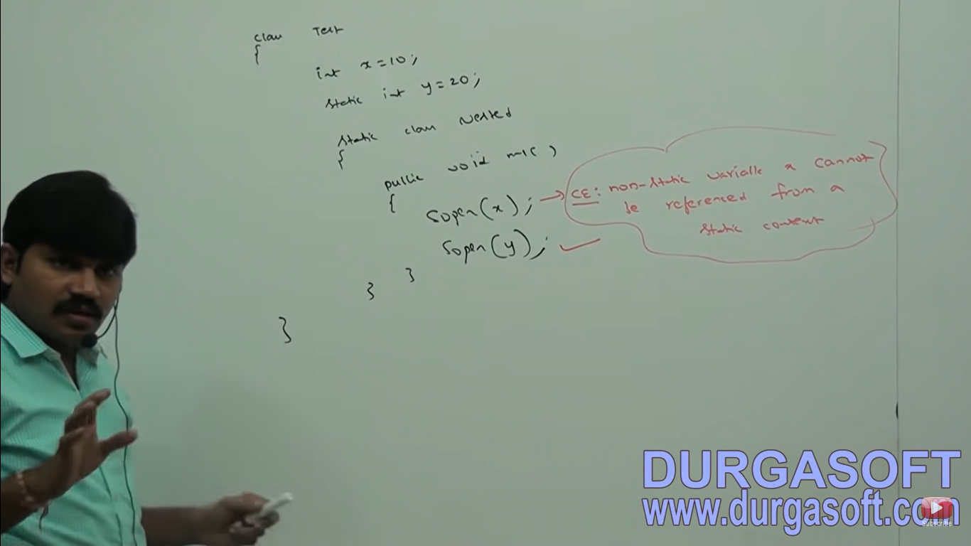



**Differences between normal regular inner class and static nested class**

1. **Regular Inner class -** Without existing outer class object there is no chance of existing inner class object that is inner class object is strongly associated outer class object.

**Static Nested class -** Without existing outer class object there maybe a chance of existing static nested class object. Hence that is static nested class object is not strongly associated with outer class object.

1. **In normal or regular class** we can declare static members. **In static nested classes** we can declare static members.
2. **In normal or regular inner class** we can’t declare main method and hence we can’t invoke inner class directly from command prompt.

**In static nested classes** we can declare main method and hence we can invoke nested class directly from command prompt.

1. **From normal or regular inner classes** we can access both static and non static members of outer class directly. **From static nested classes** we can access only static members of outer classes.

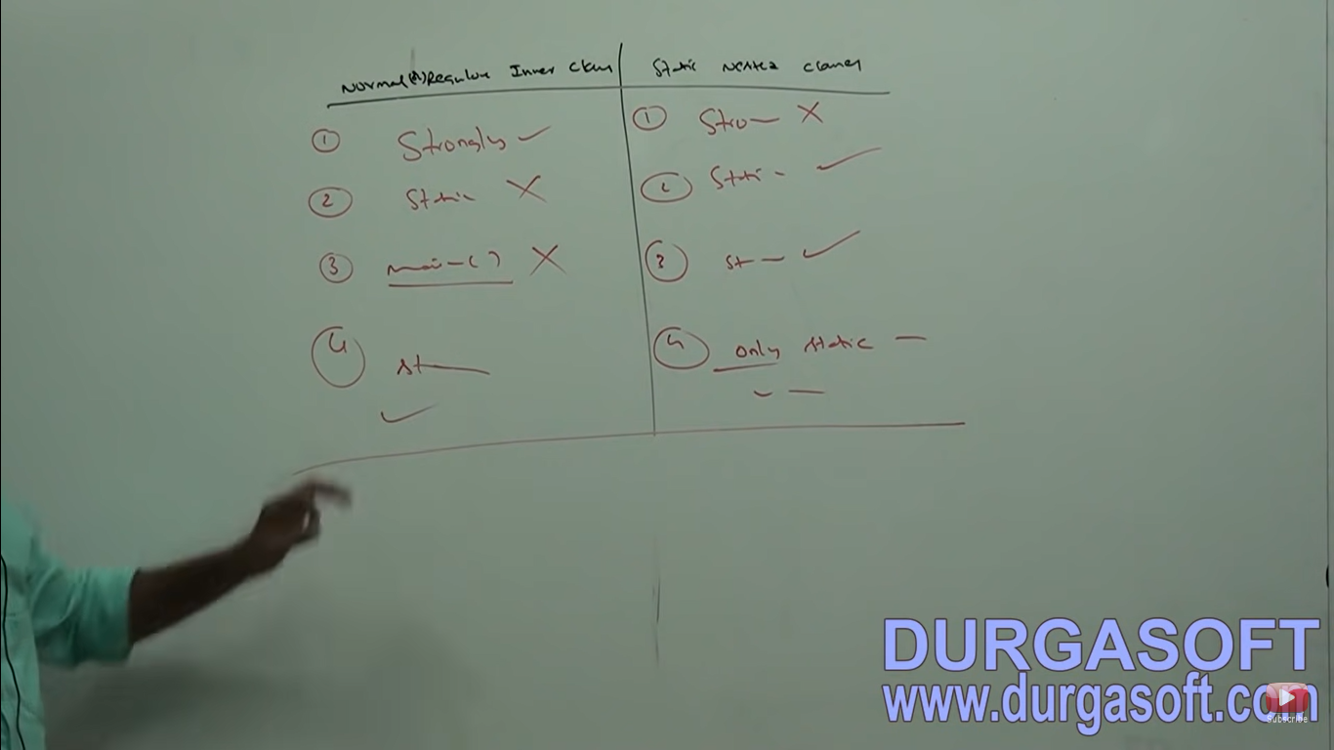

**Various Combinations of Nested classes and Interfaces**

**Case 1: Class inside a class**

Without existing one type of object if there is no chance of existing another type of object then we can declare a class inside a class.

Example:

University consists of several departments without existing university there is no chance of existing department. Hence we have to declare department class inside university class.

**Case 2: Interface inside a class**

Inside a class if we require multiple implementation of an interface and all these implementations are related to a particular class then we can define interface inside a class.

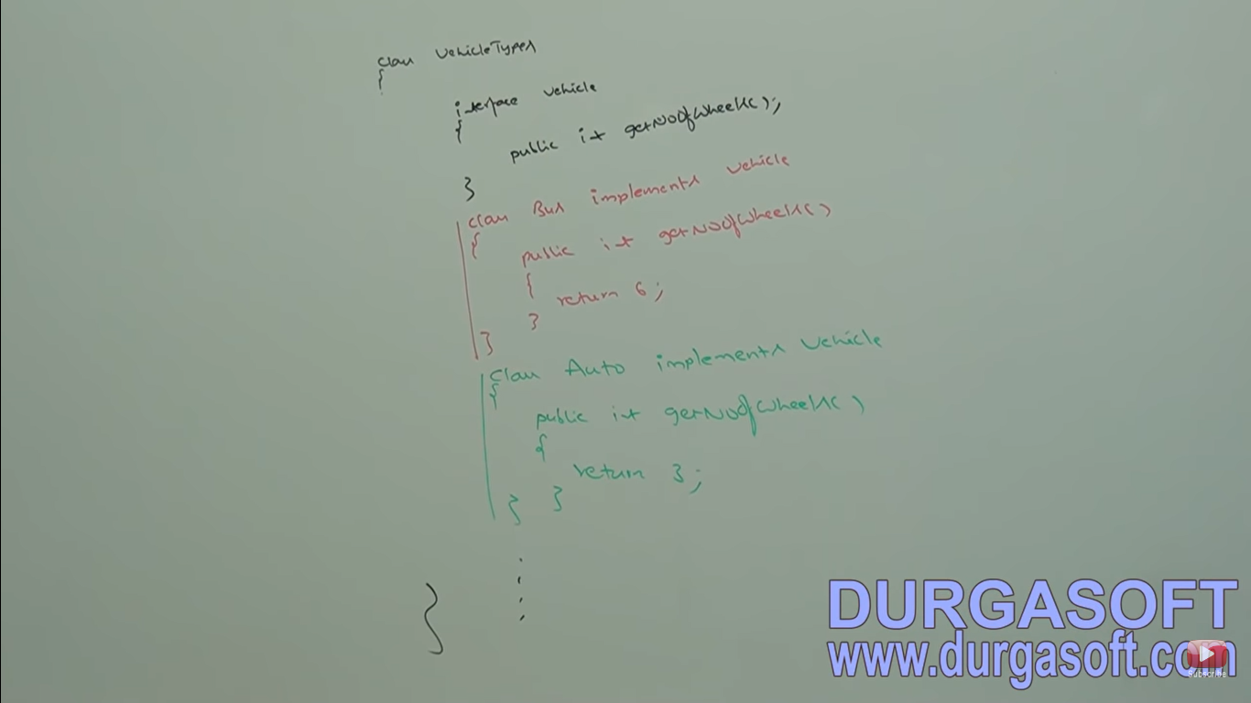

**Case 3: Interface inside Interface**

We can declare interface inside interface.

Ex: A map is a group of key-value pairs and each key-value pair is called an entry. Without existing Map object there is no chance of existing entry object. Hence interface Entry is defined inside Map interface.

Interface Map{

Interface Entry{

}

}

Both outer and inner we can implement independently.

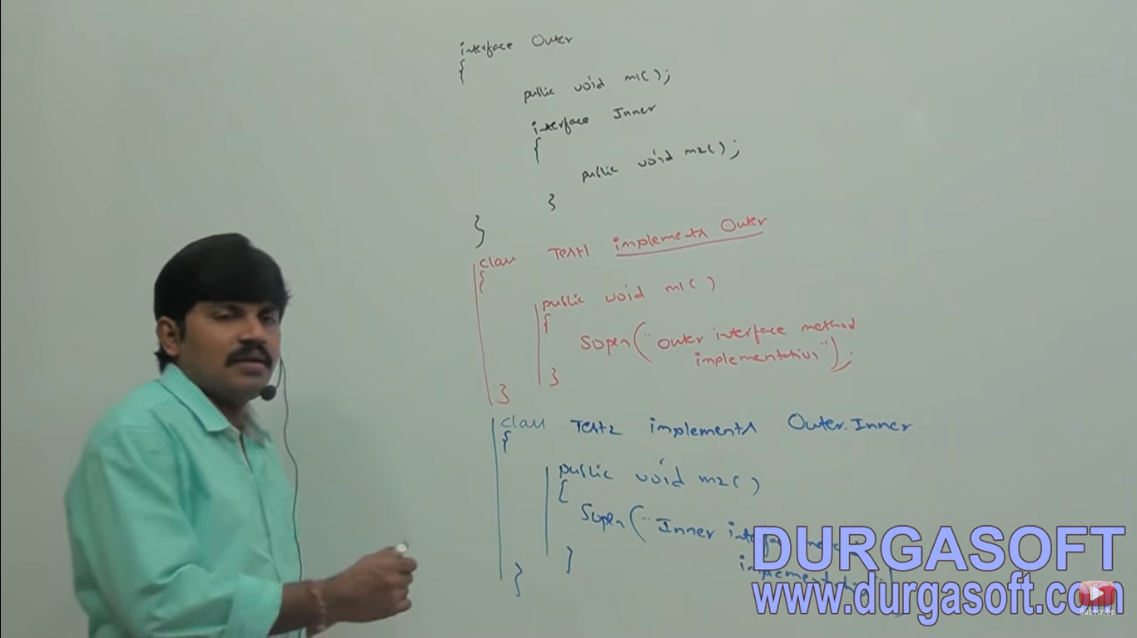

Every interface present inside interface is always public and static whether we are declaring or not. Hence we can implement interface directly without implementing outer interface. Similarly whenever we are implementing outer interface we are not required implement inner interface that is we can implement outer and inner interfaces independently.

**Case : Class inside interface**

If functionality of a class is closely associated with interface then it is highly recommended to declare class inside interface

Interface emailSource{

Public void sendEmail(EmailDetails e);

Class EmailDetails{

String to_List;

String cc_List;

String subject;

String body;

}

}

EmailDetail is required only for email service and we are not using anywhere else hence emailDetails class is recommended to declare inside EmailService interface.

We can also implement a class inside interface to provide default implementation for that interface.



In the above example DefaultVehicle is the default implementation of Vehicle interface whereas Bus is customized implementation of Vehicle interface.

Note – The class which is declared inside interface is always public static whether we are declaring or not. Hence we can create class object directly without having outer interface type object.

**Conclusions**

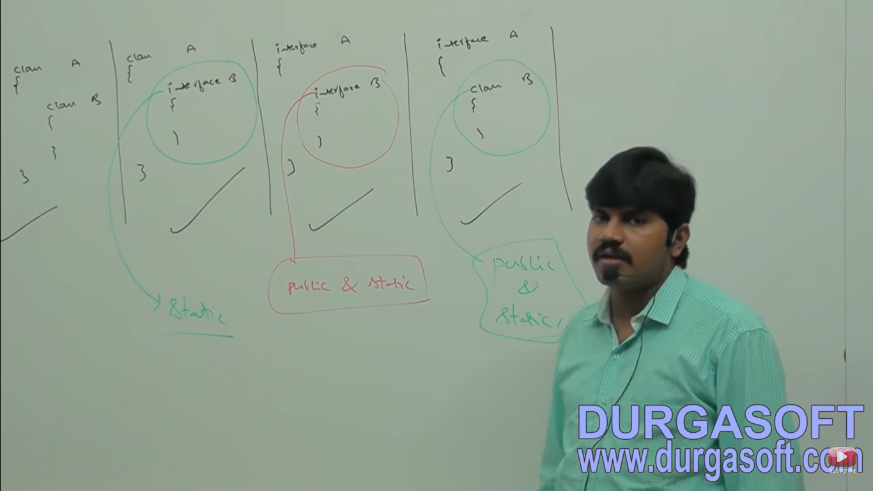

1. Among classes and interfaces we can declare anything inside anything.
2. The class which is declared inside interface is always public and static whether we are declaring or not.
3. The interface which is declared inside a class is always static but need not be public.